**Online Figures for:**

**The recovery of European freshwater biodiversity has come to a halt**

**Authors:**

Peter Haase, Diana E. Bowler, Nathan J. Baker, Núria Bonada, Sami Domisch, Jaime R. Garcia Marquez, Jani Heino, Daniel Hering, Sonja C. Jähnig, Astrid Schmidt-Kloiber, Rachel Stubbington, Florian Altermatt, Mario Álvarez-Cabria, Giuseppe Amatulli, David Angeler, Gaït Archambaud, Iñaki Arrate Jorrín, Thomas Aspin, Iker Azpiroz, Iñaki Bañares, José Barquín Ortiz, Christian L. Bodin, Luca Bonacina, Roberta Bottarin, Miguel Cañedo-Argüelles, Zoltán Csabai, Thibault Datry, Elvira de Eyto, Alain Dohet, Gerald Dörflinger, Emma Drohan, Knut A. Eikland, Judy England, Tor E. Eriksen, Vesela Evtimova, Maria J. Feio, Martial Ferréol, Mathieu Floury, Maxence Forcellini, Marie Anne Forio, Riccardo Fornaroli, Nikolai Friberg, Jean-François Fruget, Galia Georgieva, Peter Goethals, Manuel A.S. Graça, Wolfram Graf, Kaisa-Leena Huttunen, Thomas C. Jensen, Richard K. Johnson, J. Iwan Jones, Jens Kiesel, Lenka Kuglerová, Aitor Larrañaga, Patrick Leitner, Lionel L'Hoste, Marie-Helène Lizée, Armin W. Lorenz, Anthony Maire, Jesús Alberto Manzanos Arnaiz, Brendan G. McKie, Andrés Millán, Don Monteith, Timo Muotka, John F. Murphy, Davis Ozolins, Riku Paavola, Petr Paril, Francisco J. Peñas, Francesca Pilotto, Marek Polasek, Jes Jessen Rasmussen, Manu Rubio, David Sánchez-Fernández, Leonard Sandin, Ralf B. Schäfer, Alberto Scotti, Longzhu Q. Shen, Agnija Skuja, Stefan Stoll, Michal Straka, Henn Timm, Violeta G. Tyufekchieva, Iakovos Tziortzis, Yordan Uzunov, Gea H. van der Lee, Rudy Vannevel, Emilia Varadinova, Gábor Várbíró, Gaute Velle, Piet F.M. Verdonschot, Ralf C.M. Verdonschot, Yanka Vidinova, Peter Wiberg-Larsen, Ellen A.R. Welti

**Table of Contents**

**Map of sampling durations**

* **Pg. 3:** Fig. 1 | Spatial variation in the number of sampling years across all 1,816 study sites.

**Maps of trends**

* **Pg. 4:** Fig. 2 | Spatial distribution of abundance trends.
* **Pg. 5:** Fig. 3 | Spatial distribution of trends in additional taxonomic diversity metrics.
* **Pg. 6:** Fig. 4 | Spatial distribution of trends in functional diversity metrics.
* **Pg. 7:** Fig. 5 | Spatial distribution of trends in additional functional diversity metrics.
* **Pg. 8:** Fig. 6 | Spatial distribution of trends in non-native and native species.
* **Pg. 9:** Fig. 7 | Spatial distribution of trends in EPT and insect taxa

**Response correlations**

* **Pg. 10:** Fig. 8 | Pearson’s correlations, histograms, and regression plots comparing all response variables.

**Maps of drivers**

* **Pg. 11:** Fig. 9 | Distribution of stream characteristics.
* **Pg. 12:** Fig. 10 | Distribution of land cover.
* **Pg. 13:** Fig. 11 | Distribution of dam impacts.
* **Pg. 14:** Fig. 12 | Distribution of climate variation.

**Driver correlations**

* **Pg. 15:** Fig. 13 | Pearson’s correlations, histograms, and regression plots comparing all stream characteristics and environmental driver variables.

**Meta-analysis sensitivity checks**

* **Pg. 16:** Fig. 14 | Sensitivity check to examine effects of years sampled on biodiversity trend estimates.
* **Pg. 17:** Fig. 15 | Sensitivity check to examine effects of the first sampling year (start year) on biodiversity trend estimates.
* **Pg. 18:** Fig. 16 | Comparison of trend estimates between meta-analysis models.
* **Pg. 19:** Fig. 17 | Jackknife analysis of trend estimates with countries removed.

**Moving window sensitivity checks**

* **Pg. 20:** Fig. 18 | Distribution over time of sites per country in moving window analysis.
* **Pg. 21:** Fig. 19 | Distribution over time for sites of a given taxonomic resolution in moving window analysis.
* **Pg. 22:** Fig. 20 |Proportion of positive to negative sites in moving window trends.
* **Pg. 23:** Fig. 21 | High threshold moving window analysis 1.
* **Pg. 24:** Fig. 22 | High threshold moving window analysis 2.

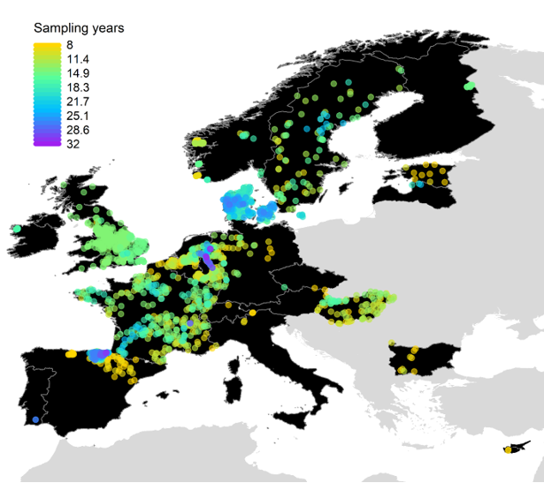

**Fig. 1 | Spatial variation in the number of sampling years across all 1,816 study sites.**

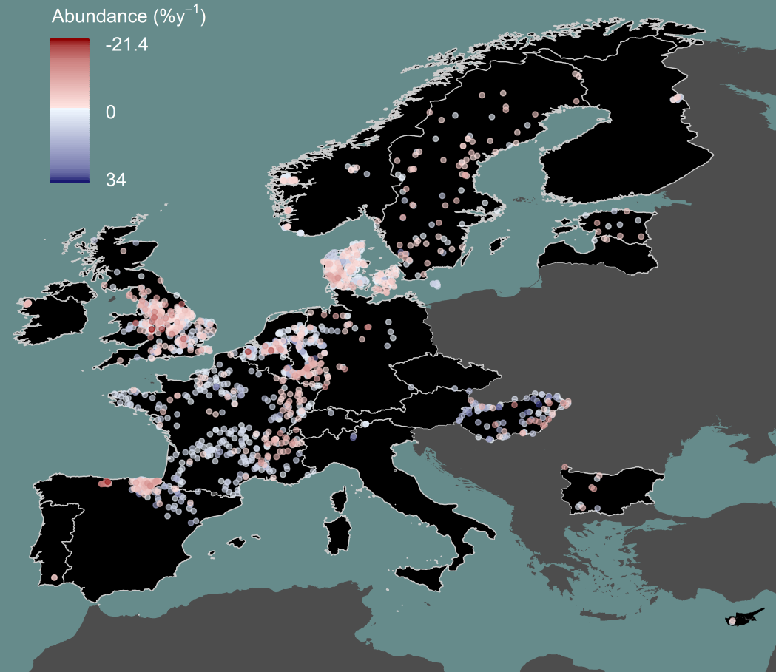

**Fig. 2 | Spatial distribution of abundance trends.** Point colors represent site-specific abundance trends in percentage change per year.

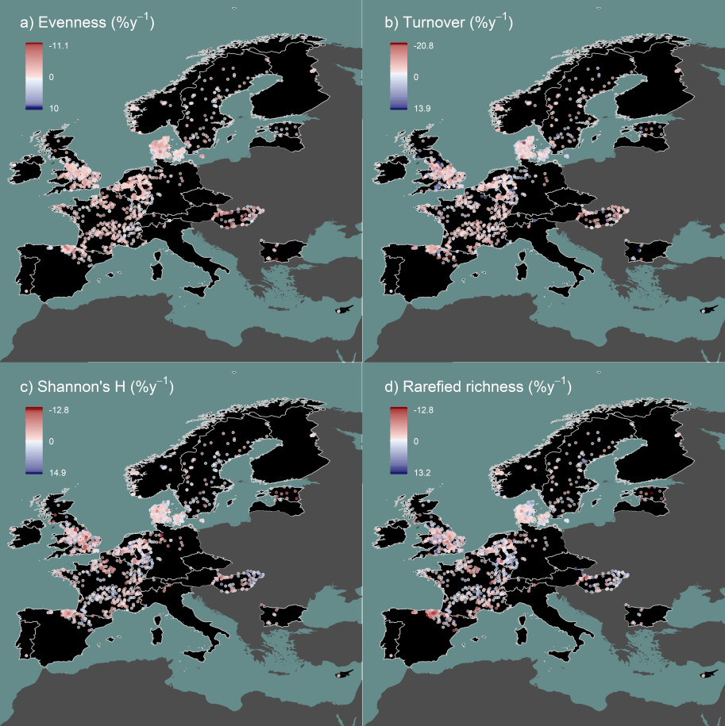

**Fig. 3 | Spatial distribution of trends in additional taxonomic diversity metrics.** Point colors represent site trends in percentage change per year for **a)** Shannon’s evenness, **b)** taxonomic turnover, **c)** Shannon’s diversity (H), and **d)** rarefied taxon richness.

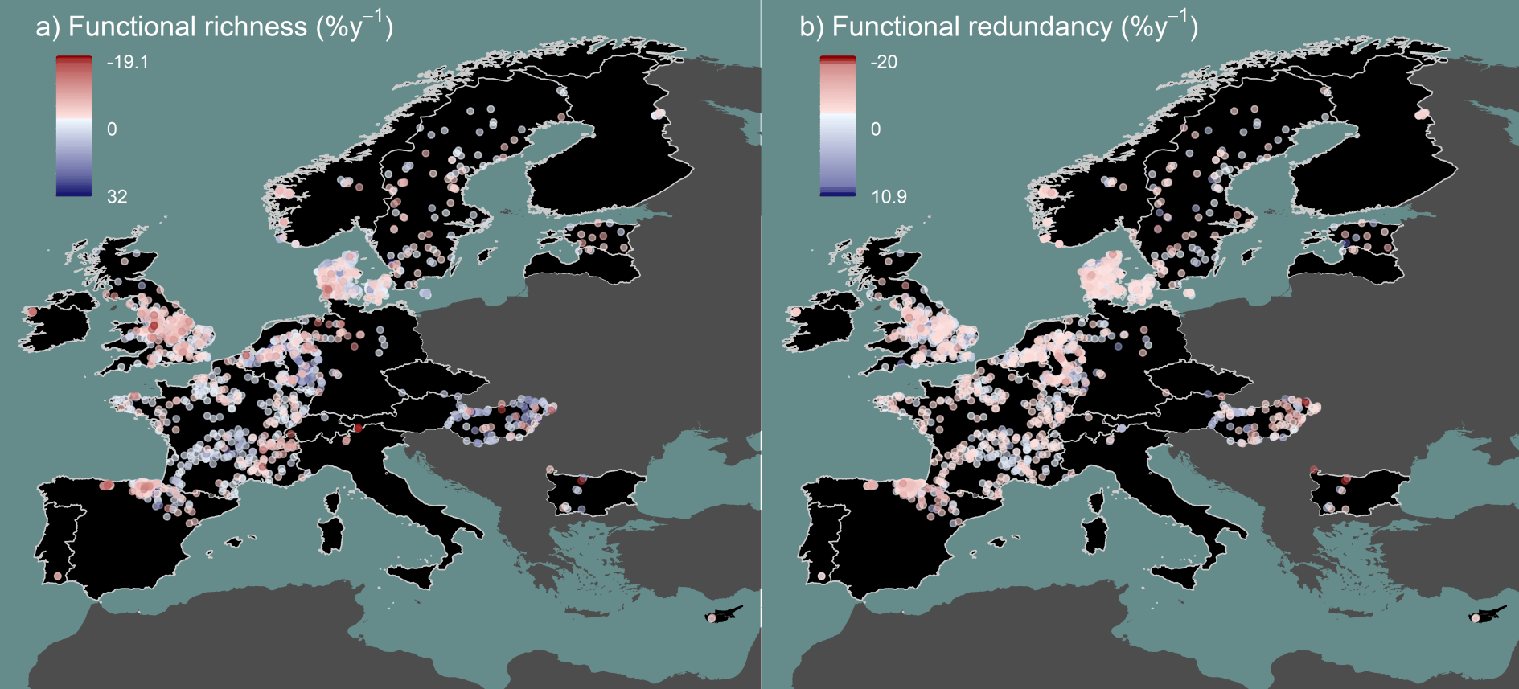

**Fig. 4 | Spatial distribution of trends in functional diversity metrics.** Point colors represent site trends in percentage change per year for **a)** functional richness and **b)** functional redundancy.

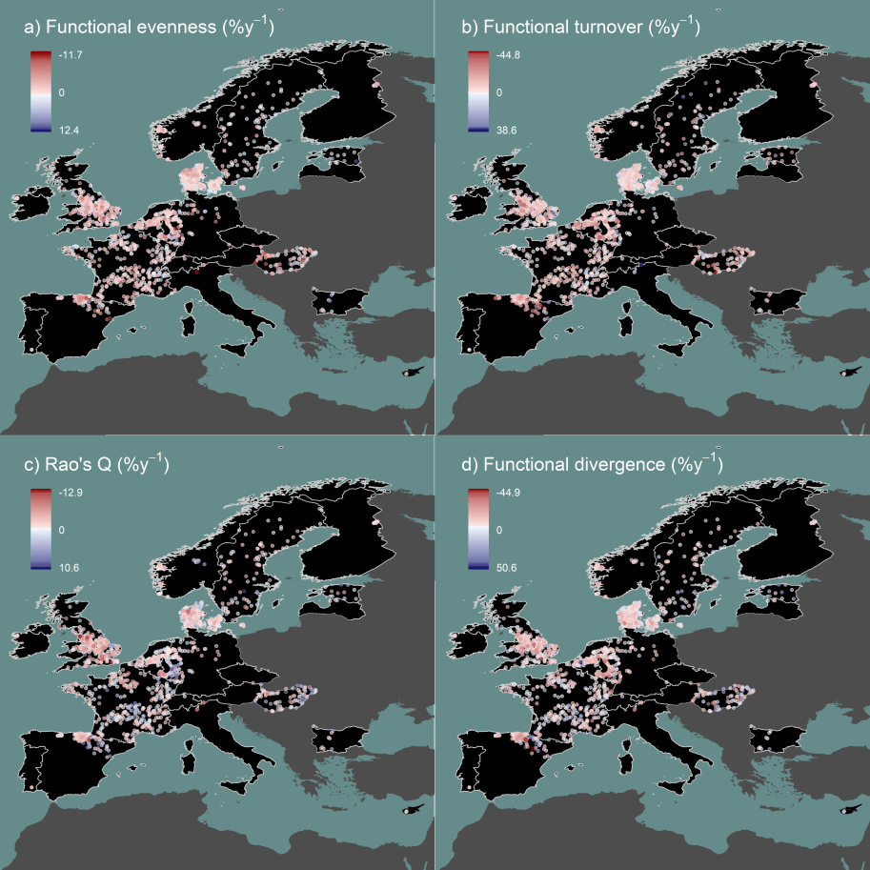

**Fig. 5 | Spatial distribution of trends in additional functional diversity metrics.** Point colors represent site trends in percentage change per year for **a)** functional evenness, **b)** functional turnover, **c)** Rao’s quadratic entropy, and **d)** functional divergence.

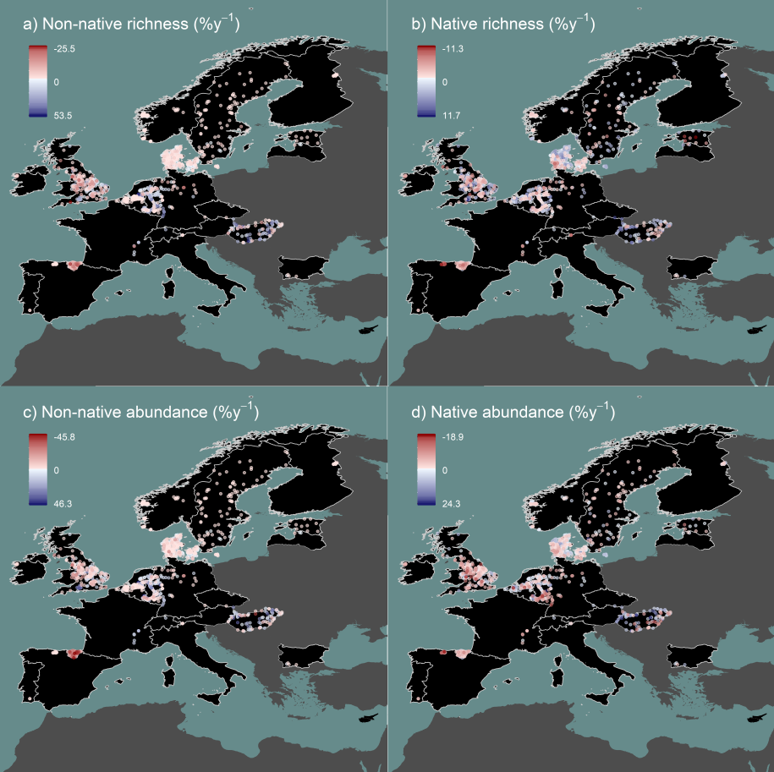

**Fig. 6 | Spatial distribution of trends in non-native and native species.** Point colors represent site trends in percentage change per year for **a)** non-native taxon richness, **b)** native taxon richness, **c)** non-native abundance, and **d)** native abundance. Only the 1,299 sites having high taxonomic resolution enabling identification of native versus non-native species are shown.

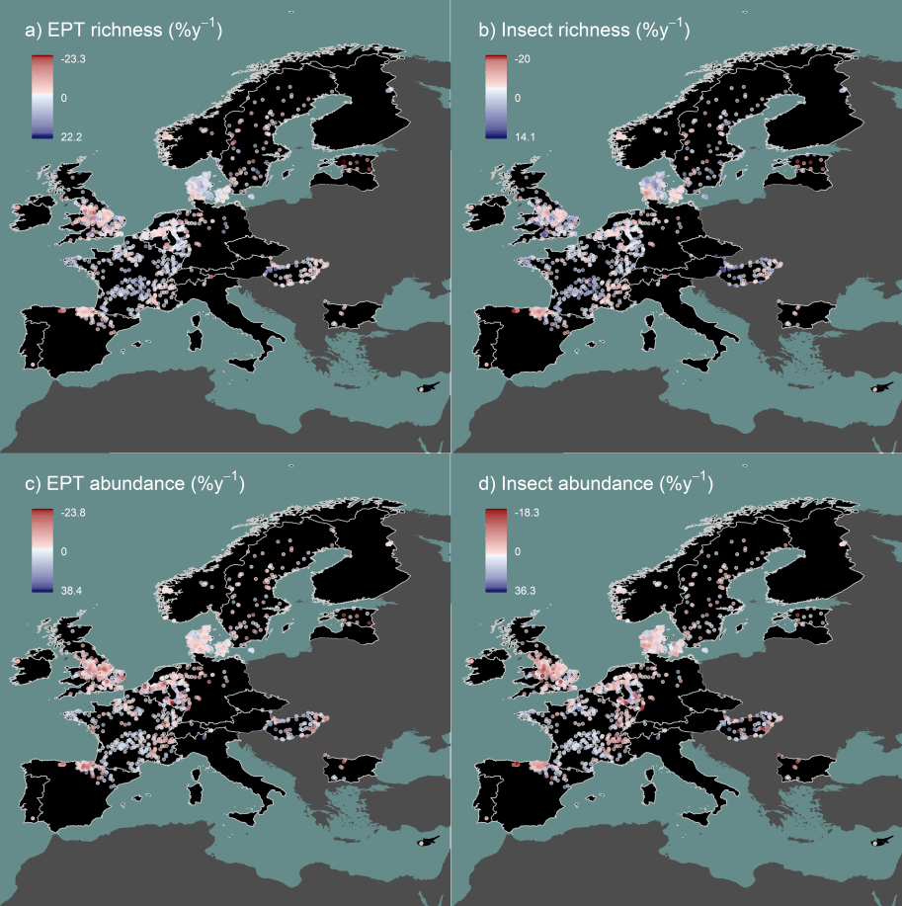

**Fig. 7 | Spatial distribution of trends in EPT and insect taxa.** Point colors represent site trends in percentage change per year for **a)** EPT taxon richness, **b)** insect taxon richness, **c)** EPT abundance, and **d)** insect abundance.

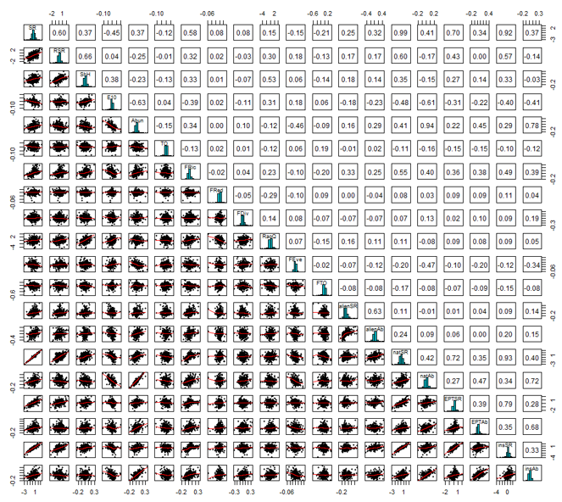

**Fig. 8 | Pearson’s correlations, histograms, and regression plots comparing all response variables.** SR = taxon richness, RSR = rarefied taxon richness, ShH = Shannon’s diversity (H), E10 = Shannon’s evenness, Abund = abundance, TO = taxonomic turnover, FRic = functional richness, FRed = functional redundancy, FDiv = functional divergence, RaoQ = Rao’s quadratic entropy, FEve = functional evenness, FTO = functional turnover, alienSR = non-native species richness, alienAb = non-native abundance, natSR = native taxon richness, natAb = native abundance, EPTSR = EPT taxon richness, EPTAb = EPT abundance, insSR = insect taxon richness, and insAb = insect abundance.

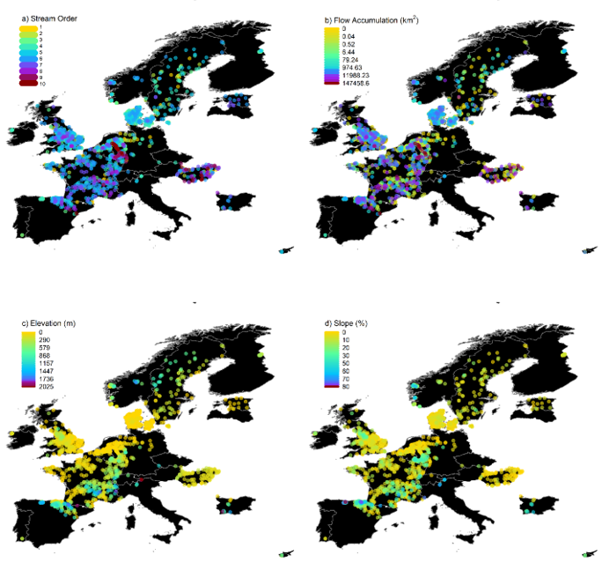

**Fig. 9 | Distribution of stream characteristics.** Spatial variation across the 1,816 study sites in **a)** Strahler stream order, **b)** flow accumulation, **c)** elevation, and **d)** slope. See Extended Data Table 4 for more details and sources of environmental data.

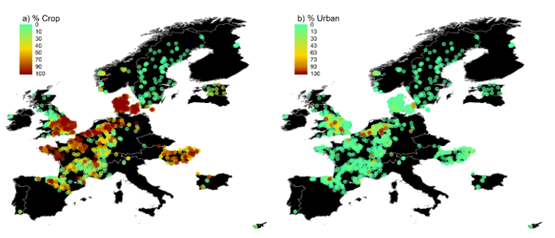

**Fig. 10 | Distribution of land cover.** Spatial variation across the 1,816 study sites in percentage upstream **a)** crop and **b)** urban land cover types. See Extended Data Table 4 for details and sources of environmental data.

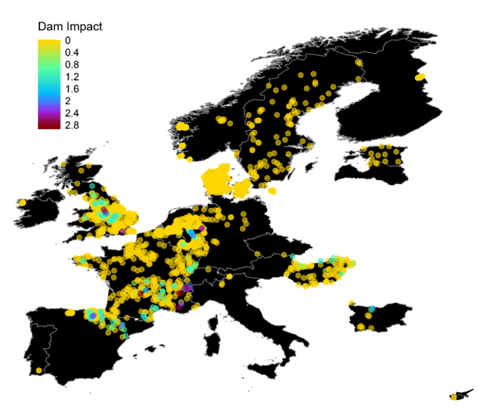

**Fig. 11 | Distribution of dam impacts.** Spatial variation across the 1,816 study sites in dam impact score based on distances between sites and upstream dams. See Extended Data Table 4 for details and the source of dam data and Methods for calculation of dam impact scores.

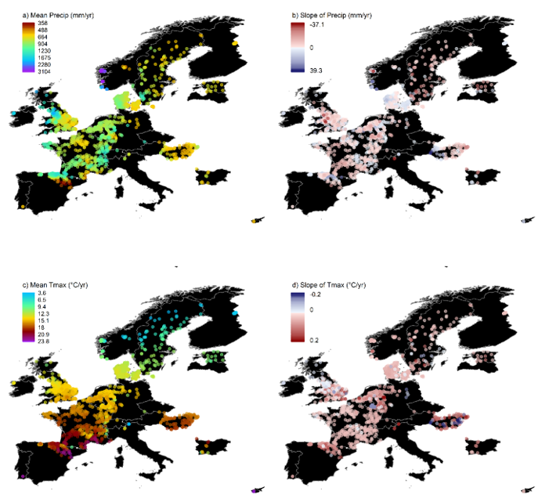

**Fig. 12 | Distribution of climate variation.** Spatial variation across the 1,816 sites and over study duration for **a)** mean cumulative annual precipitation, **b)** the change (trend) in annual precipitation per year, **c)** mean annual maximum temperature, and **d)** the change (trend) in annual mean maximum temperature per year. See Extended Data Table 4 for details and sources of climate data and the Methods for additional description of the calculations.

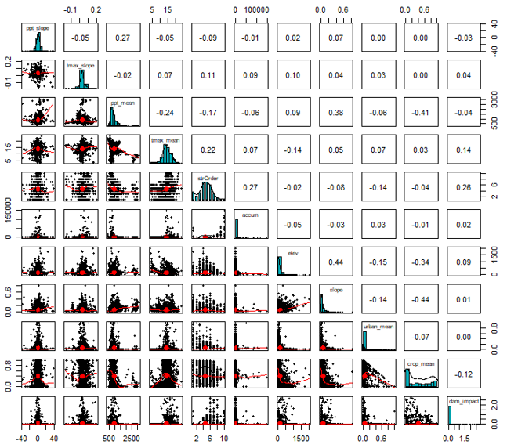

**Fig. 13 | Pearson’s correlations, histograms, and regression plots comparing all stream characteristics and environmental driver variables.** ppt_slope = the change (trend) in annual precipitation per year, tmax_slope = the change (trend) in annual mean maximum temperature per year, ppt_mean = mean annual cumulative precipitation, tmax_mean = mean annual maximum temperature, strOrder = Strahler stream order, accum = flow accumulation, elev = elevation, slope = slope, urban_mean = percentage upstream urban land cover, crop_mean = percentage upstream crop land cover, dam_impact = dam impact score. See Extended Data Table 4 and Methods for additional information on environmental data sources and processing.

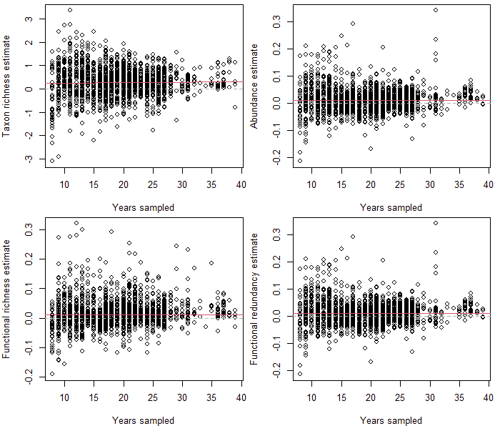

**Fig. 14 | Sensitivity check to examine effects of years sampled on biodiversity trend estimates.** Grey dashed lines mark a trend of zero and red solid lines show linear regressions relationships between years sampled and estimates.

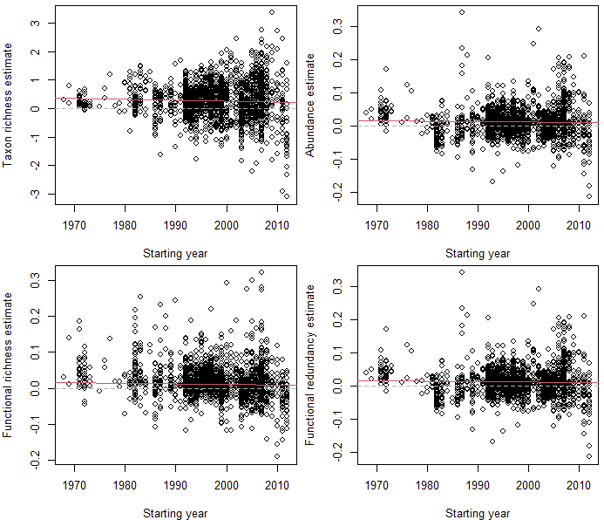

**Fig. 15 | Sensitivity check to examine effects of the first sampling year (start year) on biodiversity trend estimates.** Grey dashed lines mark a trend of zero and red solid lines show linear regressions relationships between start year and estimates.



**Fig. 16 | Comparison of trend estimates between meta-analysis models.** Model estimates were comparable across model types including **a,** Weighted Meta-analysis: the model type used and described in the main manuscript where estimates are weighted by their uncertainty, **b,** Unweighted Meta-analysis: a two stage meta-analysis with no incorporation of uncertainty, and **c,** One Stage: a hierarchical model including site identity as a random term. Scripts including model formulas can be found at https://github.com/Ewelti/EuroAquaticMacroInverts in the “R” folder.



**Fig. 17 | Jackknife analysis of trend estimates with countries removed.** Model estimates of trends for taxonomic and functional response variables with each country sequentially removed. The removed country is labeled on the y-axis. Jackknife script including model formula can be found at https://github.com/Ewelti/EuroAquaticMacroInverts under “R/ HPC_Meta_analysis_country_jacknife.R”.



**Fig. 18 | Distribution over time for sites per country in moving window analysis.** Number of sites per country included in moving window from windows of 1990-1999 to 2011-2020 with x-axis showing mean year of each window.



**Fig. 19 | Distribution over time for sites of a given taxonomic resolution in moving window analysis.** Number of sites per taxonomic resolution (species, genus/mixed, family) included in moving window from windows of 1990-1999 to 2011-2020 with x-axis showing mean year of each window.



**Fig. 20 | Proportion of positive to negative sites in moving window trends.** Change in number of sites with positive versus negative trends in moving window analysis of **a**, taxon richness, **b**, abundance, **c**, functional richness, and **d**, functional redundancy. Values of “1” indicate equal number of sites with positive and negative trends, values >1 = more sites with positive versus negative trends, and values <1 = less sites with positive versus negative trends.



**Fig. 21 | High threshold moving window analysis 1.** Trends in **a**, taxon richness, **b**, abundance, **c**, functional richness, and **d**, functional redundancy over time from sites with ≥ 15 years of sampling between the years 2000-2018, the period most represented in our dataset. This analysis included 515 sites from 11 countries. Estimates were calculated from Bayesian mixed-effects models of trends with ≥ 6 years within 10-year moving windows (windows 2000-2009 to 2009-2018). Years on the x-axis represent the mean year of each window. Gray polygons indicate 80, 90, and 95% credible intervals.



**Fig. 22 | High threshold moving window analysis 2.** Trends in **a**, taxon richness, **b**, abundance, **c**, functional richness, and **d**, functional redundancy over time from sites with ≥ 20 years of sampling between the years 1990-2020, the period most represented in our dataset. This analysis included 308 sites from 8 countries. Estimates were calculated from Bayesian mixed-effects models of trends with ≥ 6 years within 10-year moving windows (windows 1990-1999 to 2011-2020). Years on the x-axis represent the mean year of each window. Gray polygons indicate 80, 90, and 95% credible intervals.